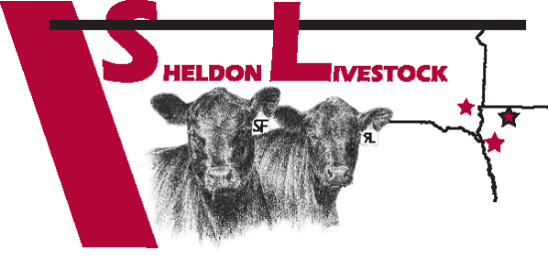
SHELDON LIVESTOCK
115 D Street – PO Box 97
Sheldon, IA 51201
Office 712.324.3144 Fax 712.324.5222
www.sheldonlivestock.com
NO IMPLANT AFFIDAVIT

I, ____________________________, am the seller of livestock sold on ___ /___ /___ at Sheldon Livestock and certify that the livestock included in this shipment have NEVER been implanted.
TOTAL # Head ______
# Heifers (____) # Steers (_____)

Name _______________________________________________
Company Name (if applicable)___________________________

City_______________________ State ________ Zip ________

Telephone (______) ___________________

Date ____________ Signature ___________________________

Persons willingly making false statements, fictitious or fraudulent statements or entries shall be liable for any damages due to inaccuracy of this certification.
Form can accompany cattle, fax to 712.324.5222 or email to office@sheldonlivestock.com

